Male Genital Washing Advice
Information for Patients

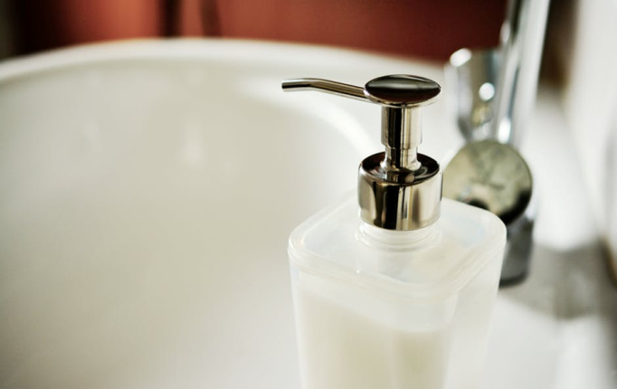
You are about to start a new drug to control your diabetes which is an SGLT2 inhibitor.
This drug works to control your diabetes by increasing the amount of sugar that is removed from your body in your urine.
It is a very effective drug but it does increase your risk of developing fungal infections of the genital skin. If this happens you may notice itching, redness and tears in the genital skin which make it uncomfortable to pull back the foreskin and to pass urine. You are also more likely to get urinary tract infections. If this happens then symptoms include stinging or burning when passing urine and the need to pass urine more frequently.
If you were to develop very severe pain in the genital area accompanied by swelling, redness, a temperature and you felt unwell then you should seek urgent medical attention.
If symptoms do develop it is important to treat them quickly to stop them getting worse.
These potential side effects can be reduced by following the tips below.

Follow the advice below – and use hydromol ointment to both wash and to protect the genital skin.
If you think you have developed any of the symptoms above ask your pharmacist for an antifungal cream-Clotrimazole cream- to use on the skin. You could also take a Fluconazole tablet from pharmacy if this does not interact with any of your other medication. Take a second tablet after 3 days and a third tablet after another 3 days. (You will have to ask your GP to prescribe the second and third tablet). If your symptoms do not start to improve in a few days speak to your GP/Diabetic team or call Chalmers Centre for more advice.
If you have urinary symptoms speak to your GP so that they can arrange to test your urine for infection.
(Pharmacy First- allows pharmacist in Scotland to dispense all of the medication mentioned above: Hydromol Ointment, Fluconazole and Clotrimazole cream, without charge if you have a GP in Scotland).
Tip 1: Avoid Soap.
Soap was first invented more than 2000 years ago. Soap makes us clean by removing the oils we produce to lubricate the skin from our bodies, as well as the skin bacteria that is contained in the oils.
Soap is no longer the best option to clean with. Soap can cause the skin to dry out too much resulting in cracking of the top layers of your skin, called superficial layers.
Micro-organisms that live on the skin can get into these cracks and this can result in itching and soreness. This particularly affects the genital skin.
Using any soap product above the waist can mean that the product will wash onto the genital skin when you rinse in the bath or shower.
Washing with just water can also dry out the genital skin. It would be best to use a soap substitute over the entire body instead.

Tip 2: Use a Soap Substitute.
A more modern way to wash is to use a soap substitute. Soap substitutes remove the bacteria that make us smell but add moisture to the skin, instead of taking it away. If your skin is well moisturised, this will help to stop it from getting itchy and sore.
Soap substitutes are widely available in all pharmacies. Depending on the brand required you can get them off the shelf or from the pharmacy team. At Chalmers we recommend Hydromol Ointment. You can use this to wash your entire body and then to moisturise or protect any irritated areas of skin after you have dried your body.

Tip 3: Pull back the foreskin when washing
Always remember to pull back the foreskin gently but fully when washing. Dry gently with a towel before replacing the foreskin.
Tip 4: If the head of the penis becomes red sore or itchy after sex or at any other time.
Stop using your normal washing product. Dissolve some kitchen salt in warm water and use this mixture to clean the head of the penis and under the foreskin twice a day for 48hours. You should also get some Clotrimazole or Canestan cream from a pharmacy and apply this after washing for 7 days. If the symptoms do not improve after 7 days, please contact Chalmers by phone for advice.
Tip 5: If the skin of the foreskin becomes tight or tears when pulling back or during sex.
Follow the above advice and wait for the skin to heal before having sex again. Then use a lubricant which does not have fragrance or added chemicals, such as Sensilube or KY.
Tip 6: Avoid bubble baths, essential oils or soap/shower gels in the bath.
They will get onto the genital skin and may cause irritation. You can buy non-soap bath additives such as Aveeno Bath oil instead.
Tip 7: Avoid wet wipes.
Do not use wet wipeson the genital skin-they are designed for babies who have much ‘tougher’ genital skin than adults.
Do not spray deodorant or any other product onto the genital skin.
Tip 8: When washing hair
It is important not to let shampoo or conditioner run onto the genital skin.
This means you should not wash your hair in the bath and when in the shower keep your head forward when rinsing products from your scalp
Tip 9: Avoid Fabric Softeners
Do not use a fabric softener or a 2 in 1 washing product when washing your clothes.
The perfume in these products gets onto the genital skin and causes drying and damage to the skin.
Tip10: Do not shave the genital skin.
Shaving the skin will damage the top layers of skin and increase your chances of recurrent discomfort. Shaving gels also contain irritant chemicals and should be avoided. ‘Trimming’ the hair may be a better option long term. Though when the skin is very uncomfortable you should not remove hair at all.

Tip 10: Do you have athletes foot?
This is a fungal infection and you can spread it from your feet to your genital area when you pull on underwear. It can cause a red itchy rash affecting the groin and the penis. If you have cracks between your toes (even if your feet are not itchy), you should buy some Terbinafine (Lamasil) cream from a pharmacy and use to clear the infection on your feet.This can stop it spreading to your genital area. Clotrimazole cream which can also be bought from a pharmacy can be used on the genital skin.
Need More Information?
If you need to contact the Chalmers Centre, our details are:
Chalmers Centre for Sexual Health
2a Chalmers Street
Edinburgh
EH39ES
Tel: 01315361070

Layout & Readability reviewed by NHSL Patient & Carer Information Team v2.0 Nov2019, For Review: Nov2021

