INVESTIGATION AND MANAGEMENT OF AMIODARONE-ASSOCIATED THYROID DISEASE

BACKGROUND
The recommended daily intake of iodine is approximately 0.2mg/day. A maintenance dose of 200-600mg amiodarone a day will provide 7-21 mg iodide/day. The associated increase in the iodine pool changes thyroid hormone dynamics, although this is not always accompanied by overt thyroid dysfunction.

Effects of amiodarone on thyroid physiology
- >50% patients on long-term amiodarone have abnormal TFTs
- Inhibition of type 1 deiodinase enzyme reduces peripheral conversion of T4 to T3.
- Entry of T3 and T4 into peripheral tissues is inhibited.
- These effects result in a rise in FT4 and a fall in TT3.
- TSH rises in the first 3 months of amiodarone treatment (due to inhibition of T4→T3 conversion in the pituitary) but TSH often normalises after 3 months.

IODINE AND AUTOREGULATION OF THYROID FUNCTION
- Expansion of the iodine pool causes an autoregulatory decrease in iodine transport and decreased thyroid hormone synthesis to protect against a surge in iodine-driven thyroid hormone synthesis. This protective mechanism is known as the Wolff Chaikoff effect.
- Failure to escape the Wolff Chaikoff effect leads to hypothyroidism.
- If these autoregulatory effects are absent or defective, the thyroid is not buffered from the effects of excessive iodine. Iodine-driven thyrotoxicosis in a previously normal gland is known as the Jod Basedow effect (Jod being the German word for iodine).
- This explains how an increased iodine load can result in either hypo- or hyperthyroidism

AMIODARONE-ASSOCIATED THYROID DYSFUNCTION
- Approximately 2% (range 1-23%) patients taking amiodarone develop amiodarone-induced thyrotoxicosis (AIT). AIT is more common in areas of low iodine intake.
- Approximately 13% (range 1-32%) patients taking amiodarone develop amiodarone-induced hypothyroidism (AIH). AIH is more common in areas of high iodine intake.

AIH
- May be caused by failure to escape the Wolff Chaikoff effect, but gender and thyroid antibodies are also implicated in the pathogenesis of AIH.
- Women with pre-existing thyroid antibodies have a relative risk of developing AIH of 13.5 compared to antibody-negative men.
- AIH may be transient or permanent. It rarely occurs after the first 18 months of treatment with amiodarone.
- Permanent AIH after withdrawal of amiodarone is almost always associated with underlying thyroid disease (eg Hashimoto’s).
- Family history of thyroid disease may predispose to development of AIH

Investigation and management
- A raised TSH in the first few months of amiodarone therapy does not necessarily indicated thyroid disease as this can be physiological and self-limiting.
- Treatment of AIH is relatively straightforward and may involve stopping/decreasing amiodarone, administering thyroxine or both.
- The aim of treatment is to normalise TSH to avoid precipitating arrhythmias

AIT
- Unlike AIH, AIT is more common in men (male:female ratio of 3:1)
- AIT may occur up to one year after drug withdrawal (long drug half-life).
- Classical symptoms may be absent due to amiodarone’s anti-adrenergic effects.
- A slightly raised FT4 and a slightly low TT3 can be physiological.
- In true AIT, the TSH should be suppressed and the TT3 is elevated.
- AIT can be divided into types 1 and 2 (table 1). The type affects management.

Table 1 | AIT type I | AIT type II
Aetiology | Iodine toxicity causes excess thyroid hormone synthesis, often in those with underlying autoimmune thyroid disease | Destructive thyroiditis
Goitre | Frequent | Infrequent
Antibodies | May be +ve | -ve
I131 uptake | Normal/ slightly | Decreased
Thyroglobulin | Normal/slightly
Hypothyroidism | Does not occur | May occur later
Doppler | /N vascularity | vascularity
Treat AIT | Potassium perchlorate and ATDs | Prednisolone
Definitive treatment | Thyroidectomy  (I131) | Thyroidectomy if no response. Follow up for possible hypothyroidism.

There are 3 questions to consider when deciding on management:
  - Can amiodarone be stopped? The following factors are relevant:
- Long half-life (22-55 days): discontinuation will not rapidly resolve AIT.
- Indication: it is less likely that it can be stopped if used to treat VT rather than AF.
- In a retrospective case series (n=28) where those with ventricular arrhythmias continued amiodarone (n=16), there was no difference between the two groups in the dose of carbimazole required, the rate of recovery of TFTs, the development of spontaneous euthyroidism or the subsequent relapse of AIT.
  - Is antithyroid Rx needed? If thyrotoxicosis is mild and amiodarone can be discontinued, it may be worth holding off antithyroid treatment.
  - If treatment is needed, which is most appropriate? (Consider aetiology)
    - Type 1 AIT: ATDs can be used. High doses are required, possibly due to high intrathyroidal iodine stores. 1g/day potassium perchlorate (maximum 6/52) can help discharge iodide stores and prevent further uptake of iodide by the thyroid. Side-effects include aplastic anaemia and nephrotic syndrome (monitor FBC and U/E). Carbimazole doses often need to start at 40-60mg (or 400-600mg PTU daily).
    - Type 2: Prednisolone inhibits deiodinase activity; may have direct effect on thyroid.

Algorithm for investigation and management of AIT
Although the subtype of AIT may be clear, it can sometimes be difficult to determine. Figure 1 illustrates a pragmatic approach to management which uses therapeutic response to help differentiate between type 1 and type 2 AIT.
  - Confirm that it is true AIT:
- Are there clinical signs to suggest AIT (though amiodarone may mask HR).
- Check TSH and TT3 as raised FT4 alone could be physiological.
  - Consider whether amiodarone can be stopped in consultation with cardiology
  - Commence carbimazole 40mg and prednisolone 40mg and review in 2/52: Carbimazole will not have taken significant effect after 2 weeks while prednisolone will have.
  - Depending on reduction in T3, decide whether this is type 1 or type 2 and rationalise treatment. Patients sometimes require treatment with both agents.
  - If medical therapy fails or amiodarone can’t be stopped, thyroidectomy may be needed
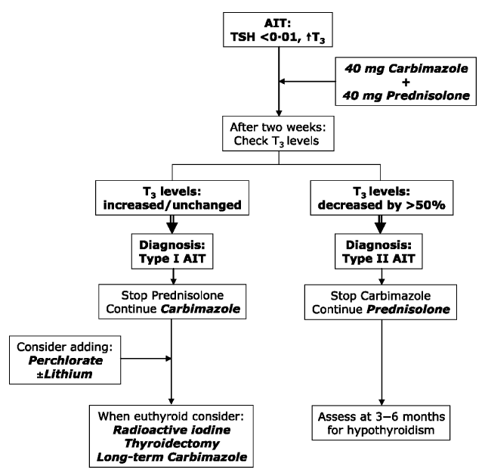
Clin Endo 70: 2-13, 2009
Figure 1

References
1. Martino E et al. The effects of amiodarone on the thyroid. Endocrine Reviews 22:240-254, 2001.
2. Harjai KJ, Licata AA. Effects of amiodarone on thyroid function. Annals of Internal Medicine 126:63-73, 1997.
3. Osman F, Franklyn JA, Sheppard MC, Gammage MD. Successful treatment of amiodarone-induced thyrotoxicosis. Circulation 105: 1275-1277, 2002.
4. Han TS, Williams GR, Vanderpump MPJ. Benzofuran derivatives and the thyroid. Clin Endo 70: 2-13, 2009

