**INFORMATION:**

**Lothian Guidance for Diagnosis and Management of Thyroid Dysfunction in Pregnancy**

Early diagnosis and good management of maternal thyroid dysfunction are essential to ensure minimal adverse effects on fetal development and maternal heath. The following are suggestions for the use of thyroid function tests in Primary Care and are derived from the UK guidelines, modified to take into account local practice.

## Diagnosis and Management of Thyroid Disease in Pregnancy

This requires close liaison between the GP, Community Midwife, Endocrinologist and Obstetrician. Much of the thyroid function testing is likely to be undertaken by the Community Midwives. However, the initial set of thyroid function tests requested for screening purposes or to check thyroid status in patients with established thyroid disorders is more likely to be done by the GP. For the majority of stable hypothyroid patients on Levothyroxine, NHS Lothian guidance suggests that 2 yearly testing is adequate, but in women of reproductive age, TFTs should be done at least annually.

## General Points

Maternal Free T4 (FT4) and Free T3 (FT3) rather than total hormone concentrations must be measured in pregnancy. ***This is because Total T4 and Total T3 increase in pregnancy due to increased serum concentrations of thyroid hormone binding proteins. It is only the FT3 and FT4 fraction (not the bound fraction) that can enter cells and modify metabolism.*** Trimester-specific reference ranges for FT3 and FT4 need to be applied for diagnosis as their concentrations fall during pregnancy (see below).

|  |  |  |  |
| --- | --- | --- | --- |
|  | **First trimester** | **Second Trimester** | **Third Trimester** |
| **TSH mU/L** | 0.09 – 2.8 | 0.20 – 2.8 | 0.30 – 2.9 |
| **FT4 pmol/L** | 10 – 18 | 9 - 16 | 8 - 14 |
| **FT3 pmol/L (see below)** | 3.2 – 5.6 | 3.1 – 5.2 | 3.0 – 5.1 |

###### References Ranges for Thyroid Function Tests in Pregnancy

**NB**: In June 2020, the FT3 reference range for non-pregnant individuals was increased by approximately 1 pmol/L to 2.4-6.0 pmol/L. **At present we no longer have reliable trimester-specific reference ranges to apply during pregnancy. Free T3 results are likely to be slightly higher in pregnancy, particularly during the first trimester, but results should be interpreted in the context of overall thyroid status**

**PLEASE NOTE:**

**The full guidance document is in resources.**

## For details of screening and Primary care Management of patients with a thyroid history – see Primary Care Management.

REFERRAL GUIDELINES

WHO TO REFER:

* **ALL women with hyperthyroidism**
* **Patients with a history of Graves’ Disease who are euthyroid or hypothyroid through radioiodine treatment or surgery – who are TRAbs positive**
* Any woman with unstable TFTs
* TPO Ab-positive women: management is covered in the section on sub-clinical hypothyroidism. These women do not necessarily need referral, but if advice is required please discuss with a consultant endocrinologist by sending an ‘Advice Only’ referral on SCI Gateway.
* Community midwife to inform obstetrician if hypothyroidism diagnosed during pregnancy.
* All women with hyperthyroid profile post-partum to assess for post-partum thyroiditis and Graves’ disease
* Any woman with a HISTORY of hyperthyroidism should also be discussed or referred.
* **All** women with hyperthyroidism in pregnancy should be seen by a Consultant Endocrinologist and a Consultant Obstetrician from early in pregnancy – please see below for full details

Specialist Management of Hyperthyroidism in Pregnancy

* Home delivery is not appropriate for women with Hyperthyroidism, nor is delivery in the Lothian Birthing Centre as neonatal team review is required in the first 24 hours of life.
* All women with a past history of hyperthyroidism who are now euthyroid should be discussed/referred to an obstetrician. All women with hyperthyroidism will have serial growth scans.
* All women with a past or current history of hyperthyroidism who are planning pregnancy should have thyroid function checked before conception and be referred for specialist advice
* The aim is for good control of hyperthyroidism on the minimum dose of carbimazole (CBZ) / propylthiouracil (PTU) possible. For those with good control of thyrotoxicosis on doses of CBZ<15mg/day or PTU<150mg/day, the maternal and foetal outcome is usually good. The American Thyroid Association recommends use of PTU in the first trimester (to reduce the risk of congenital anomalies) with consideration being given to conversion to CBZ in the second and third trimesters (to reduce the risk of maternal liver dysfunction) [9].
* **Any patient with active Graves’ Disease must have TSH-receptor antibody (TRAbs) measurement carried out at first visit to community midwife (or pre-conception) irrespective of their thyroid function test profile. If TRAbs are undetectable, they do not need to be repeated.**

**Patients with detectable TRAbs**

1. The Endocrinologist and Obstetrician should be informed of any patient with detectable TRAbs.
2. Women with detectable TRAb should be advised to deliver in hospital.
3. Further TRAb measurements and ultrasound scans will be required, the frequency of which will be advised by the Endocrinologist and Obstetrician. Typically a scan will be required each trimester, in addition to growth scans at 28 and 34 weeks (more often if control is poor).
4. Paediatricians should be informed of delivery within the first 12 hours of life and the consultant obstetrician will document this in the neonatal management plan during the antenatal period. The infant should be seen within the first 24 hours of life if TRAb are detectable at 36 weeks or if the TFTs from cord blood are abnormal
5. Cord blood should be taken for TSH, FT4 and Total T3 at delivery and the baby should have a resting heart rate checked and remain in hospital for at least 24 hours. Further repeat TSH, Free T4 and total T3 in the neonate should be carried out on the advice of the neonatal team.

###### CBZ/PTU therapy: Post Natal Management

* The endocrinologist will document a plan for the postnatal period as some women will not require CBZ/PTU treatment postnatally. However, all patients should be seen in the Endocrine Clinic 8-12 weeks post partum (or sooner if symptomatic). Vigilance for signs of postnatal thyroid storm is essential.
* CBZ is safe in breast feeding in doses at or below 15mg daily and PTU at or below 150 mg daily.

## PRIMARY CARE MANAGEMENT

## Hypothyroidism and Pregnancy

Overt untreated hypothyroidism is associated with foetal loss, gestational hypertension, placental abruption, low birthweight babies, poor perinatal outcome and severe neurodevelopmental delay. The developing foetal brain requires optimal thyroxine levels from early in the first trimester of pregnancy, before foetal production of thyroid hormones begins at 12 weeks gestation. Therefore in pregnancy there is an increased requirement for T4 [1,2,3]. The offspring of women whose free thyroxine levels are in the lowest 10% of the reference range in the first trimester of pregnancy have been shown to be at risk of significant neurodevelopmental delay at the age of two years [4]. Most cases have already been diagnosed prenatally and will be on replacement therapy. If replacement is adequate, outcomes are usually very good. The commonest causes of hypothyroidism in pregnancy are Hashimoto’s thyroiditis and treated Graves’ disease.

**The increase in serum free thyroxine (FT4) levels in women early in normal pregnancy does not occur in women who are hypothyroid. It is thus very important to ensure adequate thyroxine replacement from as early as 5 weeks gestation [5]. It is recommended that patients with established hypothyroidism should have the T4 dose increased by 25 micrograms when a pregnancy is confirmed. The recommended treatment of maternal hypothyroidism is administration of oral LT4. Other thyroid preparations such as T3 or desiccated thyroid should not be used in pregnancy as the foetal CNS is relatively impermeable to T3.**

Assessing Hypothyroidism in Pregnancy

1. Ideally women with hypothyroidism should be reviewed by their GP pre-pregnancy to ensure that they are euthyroid. All women with a history of hypothyroidism should be discussed with/referred to a consultant obstetrician. They should also be encouraged to present as soon as they become pregnant in order that their thyroxine dose may be increased and TSH and FT4 monitored regularly. Ideally, TSH should be maintained below 2.5mU/l. For patients with established hypothyroidism the ideal monitoring regimen is thus:-

* TFTs before conception (if possible)
* TFTs at diagnosis of pregnancy or at antenatal booking – but do not wait for these results before increasing the levothyroxine dose by 25micrograms as soon as the pregnancy is confirmed
* TFTs 2 weeks after the dose of T4 has been increased
* TFTs at least once in each trimester
* TFTs 2-6 weeks postpartum
* Women with adequately treated hypothyroidism do not require serial growth scans during pregnancy
* If hypothyroidism has been poorly controlled, the obstetrician will consider fetal growth assessment in the third trimester.

1. **Patients with a history of Graves’ disease who are euthyroid or hypothyroid through radioiodine treatment or surgery must have TSH-receptor antibodies (TRAbs) measured early in pregnancy irrespective of the thyroid function test profile. Women are advised not to conceive within 6 months of radio-iodine therapy.**

**If TRAbs are undetectable** they do not need to be repeated.

**If TRAbs are positive** the patient will need to be seen by a consultant endocrinologist and consultant obstetrician. It is likely that further measurements of TRAbs will be required in these patients during pregnancy. Patients should be advised to deliver in hospital and the neonatal team must be informed at delivery. Additional ultrasound scans may be required and TSH/FT4/Total T3 on cord blood may be required (see “Managing Hyperthyroidism” section below).

1. **Patients newly diagnosed with hypothyroidism whilst pregnant** should have T4 treatment commenced immediately **with a starting dose of 100 microgram daily**. A further assessment of thyroid function tests should be performed after 2 weeks to ensure FT4 is ideally 16-21 pmol/L; TSH should be less than 2.5 mU/L. Further changes in T4 dose, followed by repeat thyroid function tests may be required to achieve this “ideal” biochemical profile.

* As a minimum, patients should have thyroid function tests performed once each trimester
* If TFTs are unstable refer to a Consultant obstetrician / Consultant Endocrinologist by email as early as possible as growth scans may be required.
* Women with stable, satisfactory thyroid function tests do not need to see an obstetrician but email discussion of TFTs should be initiated by community midwife. An obstetrician will see anyone about whom there are concerns.
* GPs should reduce T4 dose to pre-pregnancy dose at 2-6 weeks post-partum and recheck TSH/Free T4 6-8 weeks later.

## Subclinical Hypothyroidism and Pregnancy

The 2017 American Thyroid Association (ATA) guidelines [9] advise that there is no strong evidence that treating maternal sub-clinical hypothyroidism improves neurocognitive outcomes in children, but there is some evidence that sub-clinical hypothyroidism is associated with increased risks of pregnancy loss or preterm delivery. There is also no evidence to support universal screening of women for thyroid disease. However, women with sub-clinical hypothyroidism who are planning pregnancy or become pregnant should be advised to seek GP review for a check of thyroid function and TPO antibodies and consideration of levothyroxine replacement depending on their results (see guidance and algorithm below). The following advice on the approach to subclinical hypothyroidism in pregnancy is based on the 2017 ATA guidelines [9]. The advice is also summarised in the algorithm below:

1. T4 therapy is recommended for TPO Ab-positive women with a TSH greater than the pregnancy-specific reference range and for TPO Ab-negative women with a TSH greater than 10.0 mU/L. A starting dose of 25-50mcg levothyroxine is recommended. If advice is needed, an ‘Advice only’ request can be sent via SCI Gateway
2. T4 therapy should be considered for TPO Ab-negative women with TSH concentrations greater than the pregnancy-specific reference range and below 10.0 mU/L, aiming to bring the TSH down to 2.5 mU/l or below. After pregnancy, levothyroxine could be withdrawn. A starting dose of 25-50mcg of levothyroxine is reasonable. If advice is required, cases can be discussed with a consultant endocrinologist by sending an ‘Advice Only’ referral on SCI Gateway.
3. TPO Ab-positive women with TSH concentrations >2.5 mU/L and below the upper limit of the pregnancy-specific reference range: Although the 2017 ATA guidance suggested that T4 therapy *may* be considered for these women, the more recent TABLET trial10 suggests that use of Levothyroxine in euthyroid women with positive anti-thyroid antibodies DOES NOT improve obstetric outcomes. Therefore, we no longer recommend Levothyroxine therapy in this group.
4. T4 therapy is not recommended for TPOAb-negative women with a normal TSH (TSH within the pregnancy-specific reference range).

###### Hyperthyroidism and Pregnancy

Patients being treated with anti-thyroid drugs require careful monitoring during pregnancy as these drugs cross the placenta and interact with the foetal thyroid. Similarly, TSH receptor antibodies (TRAbs) in maternal blood also cross the placenta and may give rise to intrauterine and neonatal thyrotoxicosis if present in high concentration. For these reasons it is essential to identify new cases of Graves’ disease in pregnancy and also to assess TRAb status in patients with previous Graves’ Disease who may be hypothyroid or euthyroid due to therapy with radioiodine, surgery or anti-thyroid drugs.

hCG shares a common subunit with TSH and therefore has thyrotropic activity. TSH is therefore often suppressed in early pregnancy and up to 60% pregnancies complicated by hyperemesis are associated with a biochemical picture of hyperthyroidism. Urgent admission should be arranged if a woman has symptoms and signs of severe hyperthyroidism or intractable vomiting. Women with biochemical thyrotoxicosis must have TRAbs measured to exclude Graves’ disease.

ALL PATIENTS WITH HYPERTHROIDISM IN PREGNANCY SHOULD BE REFERRED AND THOSE WITH A PAST HISTORY, DISCUSSED WITH A SPECIALIST. PLEASE SEE REFERRAL GUIDELINES AND NOTE:

* Home and Birthing Centre deliveries are not appropriate for women with Hyperthyroidism
* All women with a past history of hyperthyroidism who are now euthyroid should be discussed/referred to an obstetrician. All women with hyperthyroidism will have serial growth scans.
* All women with a past or current history of hyperthyroidism who are planning pregnancy should have thyroid function checked before conception and be referred for specialist advice
* Any patient with active Graves’ Disease must have TSH-receptor antibody (TRAbs) measurement carried out at first visit to community midwife (or pre-conception) irrespective of their thyroid function test profile. If TRAbs are undetectable, they do not need to be repeated

###### Significance of an “Undetectable” TSH in Pregnancy

# Some ‘normal’ pregnancies are associated with a mild transient ‘physiological’ hyperthyroidism during the first trimester. This is caused by very high levels of hCG, which has a mild stimulatory effect on the thyroid. In approximately 3% of pregnancies the TSH will be suppressed to <0.01mU/L and FT4/FT3 may be slightly elevated. It is essential to exclude Graves’ disease in such pregnancies; TRAbs should be measured and an endocrine and/or obstetric opinion sought.

## Post- Partum Thyroiditis

This is a destructive autoimmune thyroiditis causing release of pre-formed thyroid hormone and then hypothyroidism as the reserve is depleted. It occurs in 5% of women within 2-6 months of delivery or miscarriage. It presents with non-specific symptoms such as tiredness, anxiety and depression. Typically the patient will demonstrate a hyperthyroid hormone profile, which will resolve or be followed by transient hypothyroidism. Occasionally, thyroid function may not return to normal after postpartum thyroiditis. Persistent hypothyroidism may require treatment with thyroid hormone

* If a hyperthyroid profile is found (TSH <0.01 mU/L; FT4/FT3 raised) an endocrine opinion is warranted to differentiate post-partum thyroiditis from other causes of hyperthyroidism such as Graves’ disease. Measurement of TRAbs will be helpful (negative in thyroiditis).

Post-partum patients should have thyroid function tests checked at 8 - 12 weeks if they have:

* Symptoms of hyper- or hypo-thyroidism
* Goitre
* Previous history of post-partum thyroiditis or autoimmune thyroid disease
* Positive TPO Ab

Women with post-partum thyroiditis should be referred to endocrinology.

**References**

1. Toft A. 2004 Increased levothyroxine requirements in pregnancy- Why, when and how much? NEJM;351(3): 292-3.

2. Alexander EK, Marqusee E, Lawrence J et al. Timing and magnitude of increases in levothyroxine requirements during pregnancy in women with hypothyroidism. NEJM 2004; 351:241-9.

3. Demer LM, Spencer CA. Laboratory medicine practice guidelines: laboratory support for the diagnosis and monitoring of thyroid disease. Clin Endocrinol 2003; 58:138-40.

4. Pop VJ, Brouwers EP, Vader HL et al. Maternal hypothyroxinaemia during early pregnancy and subsequent child development: a 3-year follow-up study. Clin Endocrinol 2003;59 :282-8.

5. Haddow JE, Palomaki GE, Allan WC et al. Maternal thyroid deficiency during pregnancy and subsequent neuropsychological development of the child. NEJM 1999; 341: 549-55.

6. Luton D, Le Gac I, Vuillard E et al. Management of Grave’s disease during pregnancy: the key role of foetal thyroid gland monitoring. J Clin Endocrinol and Metabolism 2005;90: 6093.

7. Harborne LR, Alexander CE, Thomson AJ, O’Reilly DS, Greer IA. Outcomes of pregnancy complicated by thyroid disease. Aust NZ J Obstet Gynaecol 2005; 45(3): 239-242.

8. [Lao TT](http://www.ncbi.nlm.nih.gov/entrez/query.fcgi?db=pubmed&cmd=Search&itool=pubmed_Abstract&term=%22Lao+TT%22%5BAuthor%5D). Thyroid disorders in pregnancy. [Curr Opin Obstet Gynecol](javascript:AL_get(this,%20'jour',%20'Curr%20Opin%20Obstet%20Gynecol.');) 2005;17(2):123-7.

9. Alexander EK, Pearce EN, Brent GA, et al. 2017 Guidelines of the American Thyroid Association for the Diagnosis and Management of Thyroid Disease During Pregnancy and the Postpartum. Thyroid: 27(3), 2017: 315-389.

10. Dhillon-Smith et al. Levothyroxine in women with Thyroid Peroxidase antibodies before conception. New England Journal of Medicine 2019; 380:1316-1325.

**Original guideline by Dr G Beckett, Dr A Toft, Dr R Hughes & Dr C Calderwood**

**Updated June 2020 (*incl reference ranges) by:**

|  |  |
| --- | --- |
| **Dr C Alexander Consultant Obstetrician** | **Prof M Strachan: Consultant Endocrinologist** |
| **\*Dr M Crane Consultant Clinical Biochemist** | **Dr N Zammitt: Consultant Endocrinologist** |
| **\*Dr Jonathan Malo Consultant Clinical Biochemist** | **Dr C Morton: GP, Refhelp advisor** |

**Action Points**

## Hypothyroidism

## Assess thyroid status: Preferably prior to conception or at booking in the following situations

# Known hypothyroidism Type 1, Type 2 diabetes

# Previous history of thyroid disorder Family history of thyroid disease

## Features of thyroid disease Other autoimmune thyroid disorder

**Hypothyroid patients should be offered an appointment with consultant obstetrician**

**Measure TRAbs in all patients with history of Graves’ disease (irrespective of thyroid status)**

Patients with detectable TRAbs require special management. Inform Endocrinologist/Obstetrician as soon as possible.

**Patients with established hypothyroidism should have T4 dose increased by 25 micrograms as soon as a positive pregnancy test is found.** Further monitoring after 2 weeks and possible further changes in T4 dose may be required to ensure FT4 is 16-21 pmol/L; TSH <2 mU/L as quickly as possible.

**Further checks on thyroid function test should be made at least once in each trimester**

***If TFTs are not stable*** contact consultant obstetrician, as a growth scan may be required.

###### Cut back T4 dose to pre-pregnancy dose 2-6 weeks post-partum

**Hypothyroidism in Pregnancy**

**Post-partum Thyroiditis**

Post-partum patients should have thyroid function tests checked at 8 - 12 weeks if they have:-

* Symptoms of hyperthyroidism or hypothyroidism
* Goitre
* History of post-partum thyroiditis or thyroid disease
* Positive TPOAb

If a hyperthyroid profile is found (TSH <0.01 mU/L; FT4/FT3 raised) an endocrine opinion is warranted to differentiate post-partum thyroiditis from other causes of hyperthyroidism such as Graves’ disease. A TRAbs measurement will be helpful for this.

**Hyperthyroidism**

**All women with hyperthyroidism in pregnancy should be seen by a Consultant Endocrinologist and a Consultant Obstetrician from early in pregnancy**

**Home delivery is not appropriate for women with hyperthyroidism**

**Measure TRAbs in all patients with Graves’’ disease at booking (irrespective of thyroid status).** Patients with detectable TRAbs require special management, irrespective of their thyroid function test profile. Inform Endocrinologist and Obstetrician as soon as possible. If TRAbs are negative, they do not need to be rechecked.

**The aim is for good control of hyperthyroidism on the minimum dose of carbimazole (CBZ) / propylthiouracil (PTU) possible**

**Paediatricians should be informed on the woman’s admission to labour ward**.

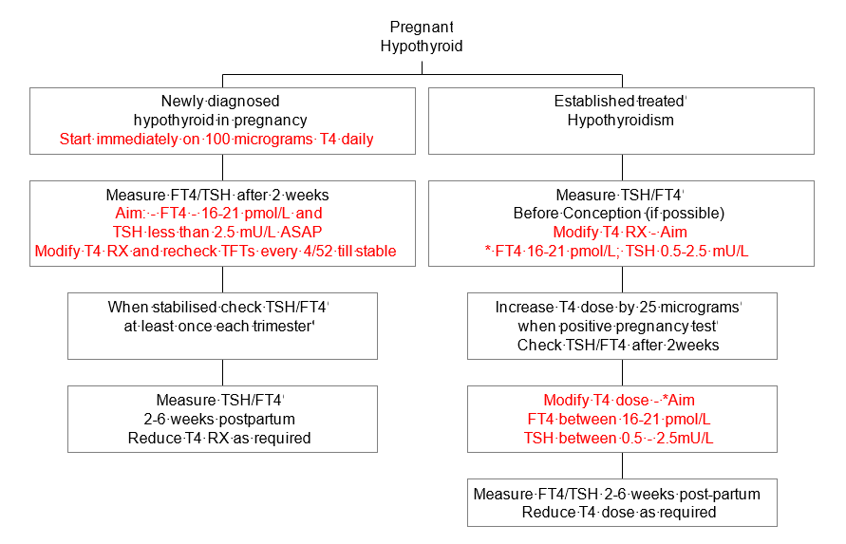

* It is important to produce this test profile (especially a FT4 of 16-21 pmol/L) as soon as possible in the pregnancy and preferably before conception

**Hyperthyroidism in Pregnancy**

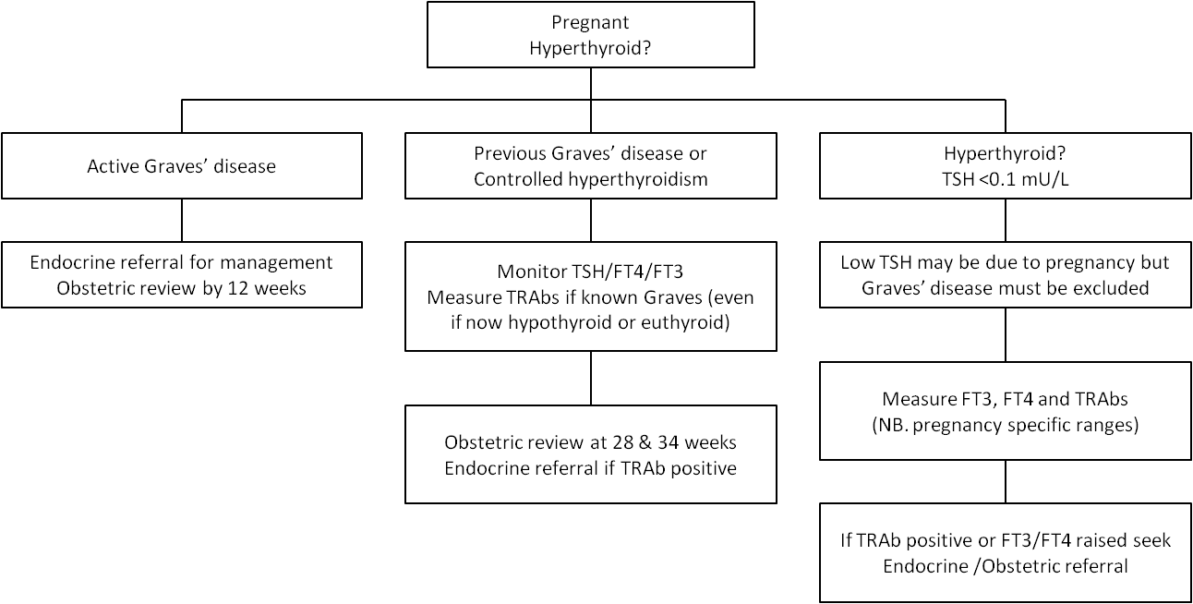

**Planning pregnancy in hyperthyroidism**

